Name: Niranjan B R

1. If You give margin to inline element it will apply to _____________
2. Top and bottom b) Left and Right c) **All sides** D) No sides

2) Which of the following is true about visibility: hidden

1. It occupies space
2. It is removed from the layout flow
3. It can still be clicked on
4. It is the same as opacity : 0

Ans: a and d

3)

**HTML**

<div class=”container”>

Some Text

</div>

**Css**

.container{

font-size : 15px;

background-color : blue;

Color : white;

padding : 5em;

}

How many pixels of padding the above layout will take

_____________________________________________________________________

4) Explain Margin-collapse and when it will occur?

_____________________________________________________________________

1. Write all the data types in Javascript

String, number, boolean, object  
________________________________________________________________

6) What is difference between primitive data types and non primitive data types

________________________________________________________________

7) What is the output of following code

var bool = true;

let result = bool ? ‘one’ : ‘two’;

console.log(result);

one

________________________________________________________________

1. How to center a div to web page using flex properties (write css code)

.class{

display:flex;

Align-items:center;

}

9) What is the difference between undefined and null in JavaScript?

Undefined : the value for the variable is not defined and kept reserve to add in future  
Null : null means purposefully mentioned as null and the value of null will be 0  
________________________________________________________________

1. What is difference between box-sizing : content-box and box-sizing : border-box in CSS?

____________________________________________________________________

11) What is the output of following code

console.log(typeof null);

|  |  |  |  |  |  |  |  |
| --- | --- | --- | --- | --- | --- | --- | --- |
| A | Number | **B** | **Object** | C | undefined | D | None of these |

12) What is the output of following code

let firstValue=10,secondValue=20,

if((firstValue<=10 && secondValue>=15)) || (secondValue < 40)){

console.log(‘true’);

}

else{

console.log(‘false’);

}

Ans: Since both the conditions are true the ans it will be “true”  
Explanation : first it will check the condition “**one”** here firstValue<=10 && (and) secondValue is >=15(set variable is 20) since these both conditions are true even if the other condition is false it will show the ans as true, why because the other condition operator is or (||).

13) Giving which property the parent element will be not get effected by the child float property?

_____________________________________________________________________________

14)

**HTML**

<div class=”container>

<p class=”child”> CSS is awesome </p>

</div>

**CSS**

**.**container{

border : 1px solid red;

}

.child{

color : current-color;

border : 2px solid initial;

}

What is the border color of p tag ?

Ans: red

15) You have to make the given layout to vertical using flex , Write you CSS code below

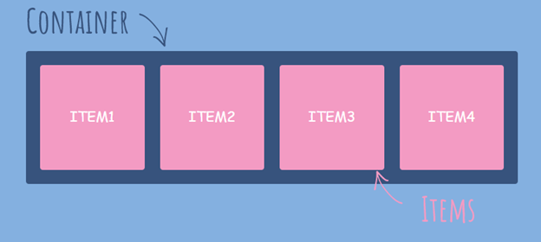

<style>

        .contentBackground{background:#84b0e0;width:600px;}

        .contentContainer{background:#37537d;display: flex;flex-direction: column;}

        .content{

            background: #f39bc3;

            width: 100px;

            height: 100px;

            border-radius: 2px;

            margin: 5px;

            display: flex;

            align-items: center;

            justify-content: center;

            color: #ffffff;

            font-family: cursive;

}

</style>

<div class="contentBackground">

     <div class="contentContainer">

         <div class="content">ITEM 1</div>

         <div class="content">ITEM 2</div>

         <div class="content">ITEM 3</div>

         <div class="content">ITEM 4</div>

     </div>

</div>

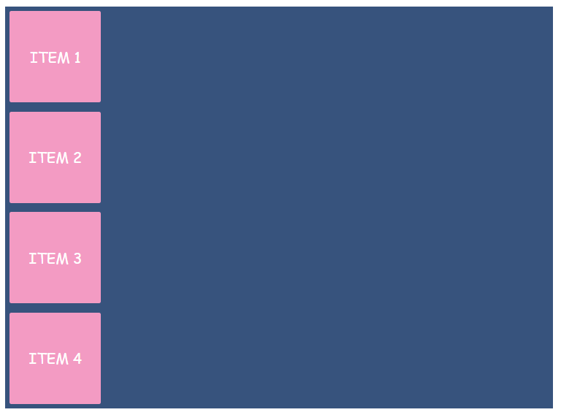

16)

**HTML**

<div class=”main__product” id=”product”> AchieversIT Training Institute Bangalore </div>

*{

color : lightgreen;

}

.main__product{

color : red;

}

#product{

color : blue;

}

div{

color : orange

}

Which color will be applied to text ?

Since css will run from top to bottom so the color will apply to the text is orange

_____________________________________________________________